Grade:

Course Code/Title:

Section Number:

Instructor Name :

Semester/Year:

LAB REPORT TITLE:
EXPERIMENT1 - LINEAR HEAT CONDUCTION
Student Name(s) | Student Number | Student Signature

Please list any others who contributed to this lab report:

_____________________________________

Student declaration:
By signing above, I attest that I wrote this assignment\lab report alone or with the help of the students I have listed above. I understand that any act of plagiarism will be treated as academic misconduct for which provisions stipulated in the Student Code of Conduct should apply.

Abstract
The aim of the experiment is to study the factor which could affect linear conduction heat transfer. The results demonstrate that linear heat transfer obeys Fourier's law. Different materials (conductivity) and cross-sectional area have different flux rates. Compared with stainless steel, Brass has better heat conductivity and paper's is tiny. A large temperature drop occurs on between contact surfaces of test section and cooler section

Table of Content
1. Introduction
2. Theory
3. Procedure
4. Results and Discussion
5. Sources of Error
6. Conclusion
7. References

Table of Figures
Figure 1:
Figure 2:
Figure 3:
Figure 4:

Table of Tables
Table 1:
Table 2:

Introduction
Thermal conduction is the transfer of heat energy in a material due to the temperature gradient within it. It always takes place from a region of higher temperature to a region of lower temperature. A solid is chosen for the experiment of pure conduction because both liquids and gasses exhibit excessive convective heat transfer. For practical situation, heat conduction occurs in three dimensions, a complexity which often requires extensive computation to analyze. For experiment, a single dimensional approach is required to demonstrate the basic law that relates rate of heat flow to temperature gradient and area.
In this experiment, you are going to demonstrate linear heat conduction according to the measure the temperature distribution for steady-state conduction of energy through a uniform plane wall and demonstrate the effect of a change in heat flow and To determine the thermal conductivity k (the constant of proportionality) of a metal specimen (good conductor).

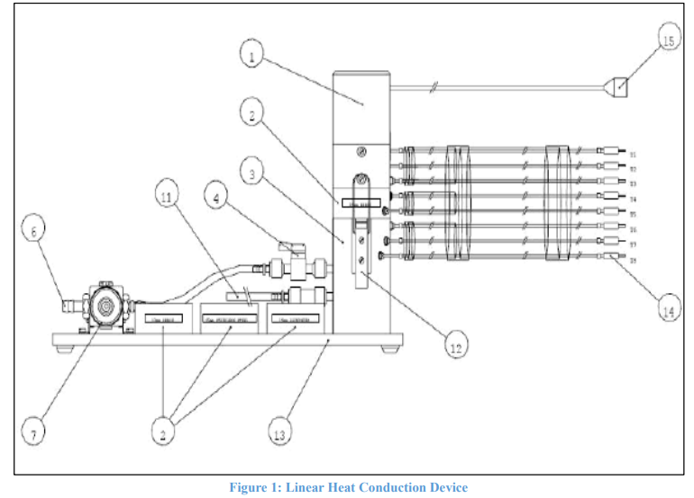

Theory
Heat transfers in different modes conduction, convection, and radiation. In this experiment, you are going demonstrate heat transfer in conduction. Conduction can take place in gasses, liquids, and solid. In solids, conduction accrues due to vibrations of molecules, and in gasses and liquids due to collisions and diffusion. In general, the rate of heat conducted depends on medium geometry of the material used, thickness, and temperature difference across the medium. Heat conduction accrues in a diversity of engineering applications and can be calculated using Fourier’s law of heat conduction:
𝑄̇ 𝑐𝑜𝑛𝑑 = −𝑘 𝐴 𝑑𝑇 /𝑑𝑥
Where,
𝑄̇ 𝑐𝑜𝑛𝑑 is the heat conduction rate (W),
(𝑘) is the thermal conductivity of the material (W/m.oC),
(𝐴) Heat transfer area (m2 ),
𝑑𝑇 the difference between two temperatures where conduction occurs,
𝑑𝑥 is the thickness of the material.
When heat transfers over any material it faces resistance depending on the type of this material and its length, therefore, it is important to introduce the term Overall Heat Transfer Coefficient U. 𝑅 = 1 /𝑈 , 𝑅 = ∆𝑋/ 𝑘 𝑄̇ ,𝑐𝑜𝑛𝑑 = 𝑈 𝐴 𝑑𝑇
Where R is the resistance, U is the overall heat transfer coefficient (W/ms.K), and ∆𝑋 is the distance between two surfaces where conduction take place.

Procedure
– A Steady State Heat Conduction

Procedure
1. Start your experiment only after you receive operating and
safety practice by your instructor!
2. Insure that water is supplied to the cold section.
3. Insure that the flexible water connection is directed to the drain.
4. Insure that each thermocouple is connected to its socket at part
(K) of the service unit.
5. Insure that switch (B) on the service unit is toward the Manual
setting.
6. Insure that you select V on the measurement selection switch
(E)
7. Turn on the main standby switch (A)
8. Watch the voltage readings on top panel meter (D) (since you selected V on step number 6).
9. Starting from zero voltage increase the volt gradually to 12V
10. Make sure that the temperature switch (G) is located at T1, as a start, you will change it later.
11. The required temperature reading is selected via switch (G), select T1 now.
12. Wait for 10min (for a steady-state condition) and watch the temperature on the adjacent panel
meter (J).
13. After reaching a steady state, take the reading of T1 and change the temperature reading switch to
display other temperatures.
14. Fill the table below of the readings and don’t forget to mention the units!
15. Knowing that the distance between each thermocouple is 0.015m fill in the table the position of
each temperature sensor along the brass bar

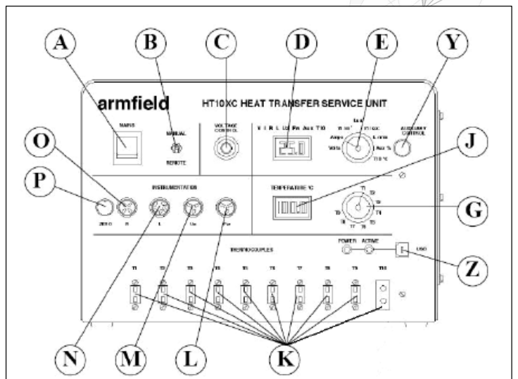

Figure2: HT10XC Service Unit

A Steady State Heat Conduction

In this exercise, you will use Fourier Rate Equation to determine the thermal conductivity of a brass and stainless steel material by using two different intersection specimen. You will need the results collected from the previous exercise.

Procedure

Figure 3 represent the temperature distribution across the cylindrical bar, find the thermal conductivity of the brass specimen by following the following steps

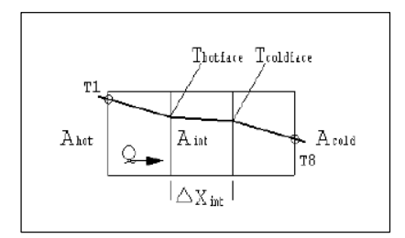

Figure 4: Diagram showing heat transfer through the brass intermediate section

1. Since we are assuming almost zero heat lost in the heat transfer process. Find the heat transfer rate that is generated as electrical work to the brass bar by using 𝑄̇ = 𝑉 × 𝐼
2. The voltage and the current inputs can be read on panel D by adjusting switch E.
3. Measure the length of the intermediate section ∆𝑋𝑖𝑛𝑡 by using vernier caliper
4. Measure the diameter D of the brass in the intermediate section by using vernier caliper.
5. Find the cross sectional area of the brass bar 𝐴𝑖𝑛𝑡 = 𝜋 𝐷𝑖𝑛𝑡 2 4 . This representing the area of the hot and cold wall surfaces.
6. Find the temperature of the hot and cold wall surfaces using the graph obtained.

𝑇ℎ𝑜𝑡 = 𝑇3 – (𝑇2 − 𝑇3 )/2

𝑇𝑐𝑜𝑙𝑑 = 𝑇6 + (𝑇6 − 𝑇7 )/2

7. Finally calculate the value of the thermal conductivity of the intermadiate section 𝑘𝑖𝑛𝑡
8. Repeat the experiment after replacing the other intermediate section made of stainless steel

Results and Discussion

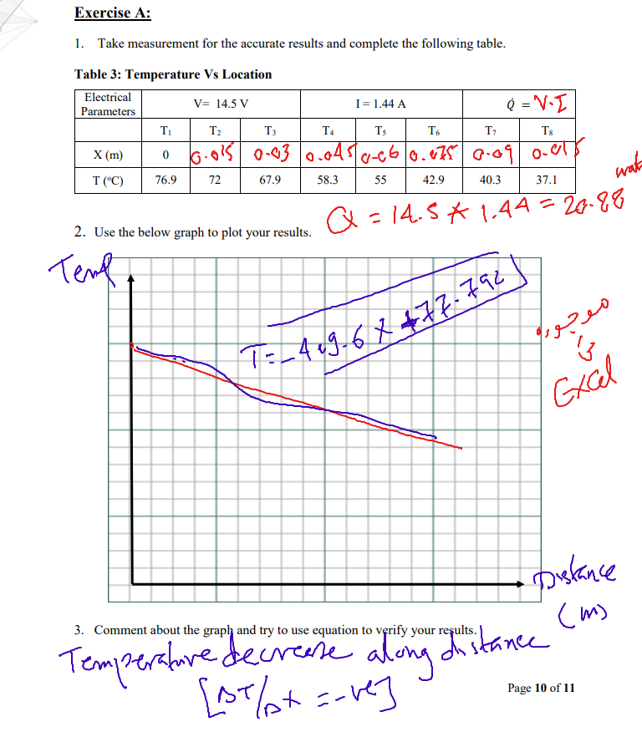

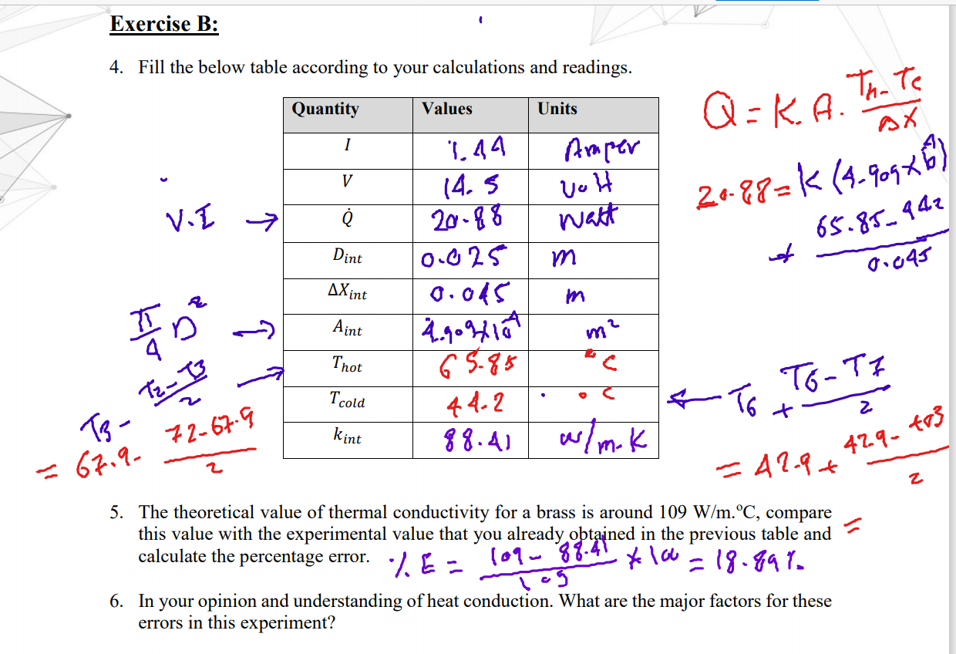

Sources of Error
1 Error Sources associated with Loss of Steady-State Conditions The problem of deviation from steady-state conditions is entirely instrument related. The specific error sources are temperature variation and non-linear heat flow
2 Error Sources associated with Q/A
HFM instruments measure Q/A using thin heat flux sensors, one embedded in each instrument platen. The heat flux sensor designs for this particular instrument are proprietary, making it difficult to comment in detail.
3 Error Sources associated with ∆x ∆x is the one source of error that is entirely specimen related, and thus entirely within the control of the operator. Obtaining an average ∆x value for a given specimen is straightforward enough; the problem is the standard deviation around that average. The various sources of error, whether macroscopic (lack of planarity, in the form of undulations or hollows, or lack of parallelism) or microscopic (lack of smoothness) can be gathered together under a single heading: specimen preparation tolerance
. 4 Error Sources associated with ∆T There are a number of error sources associated with the measurement of ∆T, all of them basically related to the Type E thermocouples used by the instrument under discussion to measure T1 and T2 (∆T = T1 – T2).

Conclusion

The experiment requires us to explore the effect of material and cross-sectional area to the heat transfer and the influence of thermal insulation and conducting compounds on the thermal conduction.

References

1 .FOURIER'S LAW, available from:

http://www.thermopedia.com/content/781/

Properties: Stainless Steel -Grade 304 (UNS S30400) -AZoM
https://www.azom.com/properties.aspx?ArticleID=965

